

**Dr. BABASAHEB AMBEDKAR MARATHWADA UNIVERSITY, AURANGABAD**

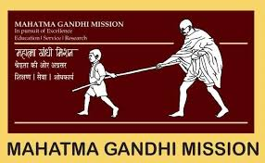

**MGM’S**

**Dr. G. Y. Pathrikar College of Computer Science & Information Technology, Aurangabad -431003**

**(2019-2020)**

**Project Report**

**On**

**“Medical Billing Management System”**

**In partial fulfillment of requirement for the degree of Bachelor of Computer Science**

**Submitted By-**

**Komal Ramesh Chavan**

**Guided By -**

**Dr. Yogesh Rajput sir**



**Dr. BABASAHEB AMBEDKAR MARATHWADA UNIVERSITY, AURANGABAD**



**MGM’S**

**Dr. G.Y. Pathrikar College of Computer Science & Information Technology, Aurangabad – (431003)**

**‘CERTIFICATE'**

This is to certify that, **Komal Ramesh Chavan** have successfully completed the project report on “Medical Billing System” for partial fulfillment of course B.Sc. (Computer Science) Sixth Semester, affiliated to Dr. BabasahebAmbedkarMarathwada University, Aurangabad, during the Academic year( 2019-2020).

**Roll no: - (A0193009)**

**Project Guide Head of Department**

**Dr. Yogesh Rajput Dr. S. Azade**

**Examiner**